**Lecture-1**

**Introduction**

**Industry 4.0 definition and concept:** Industry 4.0 (I4.0) is considered as a revolution for having significant impact in social, political, and economic shift from the digital age of the late 1990s and early 2000s to an era of embedded connectivity. It has blurred the demarcation between physical, digital and biological worlds. I4.0 represents advancements in computational technologies and their integration into industries. Focus involves the use of digital connectivity, and data-driven decision-making to transform manufacturing and service sectors.

**Industry 4.0 a Revolution:**

Industry 4.0 is considered another industrial revolution because of its multi-facet impact affecting individual to international forums.

*Political implications:*

1. Policy formulation to address issues related to data privacy, cybersecurity, intellectual property, labor rights, striking a balance between fostering innovation and protecting citizens’ privacy.
2. Digital Divides and Inclusivity: Digital functionality in sectors like banking, social networking, and e-governance has potential to exacerbate the digital divides, as some social groups might struggle to keep up with the pace of technological advancement.
3. International Competition and Trade: Governments will need to consider how to position their countries competitively in the international market, foster innovation and research, and handle potential trade disputes related to emerging technologies.
4. National Security and Cybersecurity: As critical infrastructure becomes more connected and digitized, the risk of cyber threats and attacks increases. Governments must invest in robust cybersecurity measures to safeguard their countries' economic and political stability.

The socioeconomic disruptions caused by Industry 4.0 can lead to political instability and public discontent if not managed properly. Collaboration between governments, industries, and civil society has become further crucial for implementing proactive, forward-thinking, and adaptable policy decisions

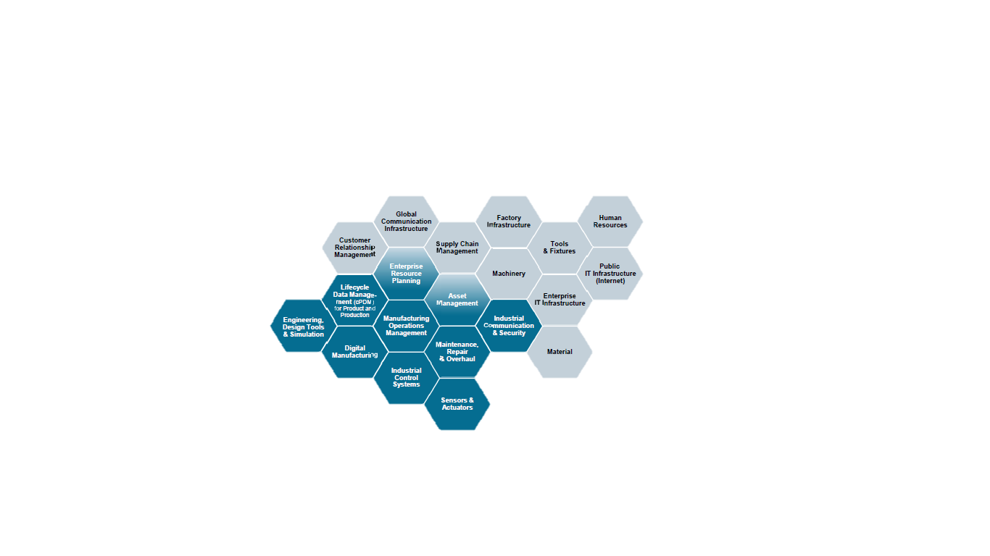

*Economical implications:*

On oneside I4.0 presents opportunities for growth, innovation, and efficiency, it also introduces challenges related to job displacement, inequality, and the need for significant investments in education and infrastructure.

1. Productivity and Efficiency Gains: Industry 4.0 technologies, such as automation, precision, and robotic based manufacturing can significantly improve productivity and efficiency in manufacturing and service sectors. Automated processes can reduce production times, lower operational costs, and optimize supply chains. Digitalization and smart manufacturing enable firms to produce higher-quality goods, meet customer demands more effectively, and reach global markets efficiently.
2. Supply Chain Transformation: The integration of IoT and advanced analytics in supply chains improves transparency and traceability. This enhances inventory management, reduces waste, and allows for more agile responses to disruptions.
3. Customization and Personalization: Industry 4.0 enables greater product customization and personalization. Companies can cater to individual customer needs and preferences, fostering customer loyalty and satisfaction.
4. Infrastructure Investment: The full realization of Industry 4.0 requires significant infrastructure investment, including 5G networks, broadband connectivity, and data centers. It may disrupt traditional industries, leading to the decline of certain sectors and the rise of new ones.

The societal impact of Industry 4.0 is profound and touches various aspects of human life. Reskilling and upskilling programs become crucial to help workers transition to new roles in the digital economy. Employment and workforce changes can lead to job displacement, affecting various industries and occupations. On oneside Industry 4.0 advancements can significantly impact healthcare, from telemedicine and remote patient monitoring to personalized medicine based on data analysis. On the other-side AI and autonomous systems raise ethical questions about accountability, transparency, and the impact of decisions made by machines on human lives.

**Historical Context:**

*First Industrial Revolution (Late 18th to early 19th century):*

The First Industrial Revolution, also known as the Industrial Revolution, began in the late 18th century in Britain and later spread to other parts of Europe, the United States and parts of Asia. It was characterized by a shift from agrarian, manual labor-based economies to those reliant on mechanized manufacturing. Key developments included the invention of the steam engine, textile machinery, and the mechanization of agriculture. This revolution transformed production processes, increased productivity, and led to the growth of factories and urbanization.

*Second Industrial Revolution (Late 19th to early 20th century):*

The Second Industrial Revolution, sometimes referred to as the Technological Revolution, occurred in the late 19th and early 20th centuries. This period was marked by significant advancements in technology, especially in the fields of electricity, steel, and transportation. Key innovations included the development of the telegraph, telephone, electrical power generation, the internal combustion engine, and the assembly line. These advancements led to the mass production of goods, the rise of industrial giants, and the expansion of global trade and transportation networks.

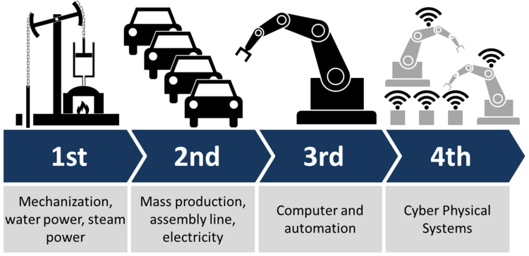

*Third Industrial Revolution (Late 20th century):*

The Third Industrial Revolution, also known as the Digital Revolution or the Information Age, emerged in the late 20th century. It was characterized by the widespread adoption of computers, digital technology, and the internet. Key developments included the invention of microprocessors, personal computers, the internet, and the expansion of telecommunications networks. The Third Industrial Revolution transformed industries by digitizing processes, enabling automation, facilitating global communication, and creating new business models. It also gave rise to the knowledge economy and the rapid exchange of information.

*Fourth Industrial Revolution (Current era):*

The Fourth Industrial Revolution, also known as Industry 4.0, represents the ongoing wave of technological advancements that began in the late 20th century and continues today. It builds upon the foundation of the Third Industrial Revolution but involves the integration of digital technologies, connectivity, and data-driven decision-making. Industry 4.0 is characterized by the emergence of cyber-physical systems, the Internet of Things (IoT), artificial intelligence (AI), big data analytics, and advanced robotics. It aims to revolutionize manufacturing processes, create smart factories, optimize supply chains, and enable the development of innovative products and services.

Each industrial revolution has brought about significant changes in society, the economy, and the way we work. They have transformed industries, improved living standards, and reshaped global trade and communication. The Fourth Industrial Revolution, Industry 4.0, represents the latest phase in this ongoing process of technological advancement and digital transformation.

**Requirements of Industry 4.0**

Industry 4.0 is the integration of many emerging technologies that collect and leverage Industrial Big Data to drive manufacturing and supply chain automation, provide real-time insights, and close communication feedback loops for faster decision-making in the manufacturing process. The next stage of factory automation is only possible if an organization’s cyber-physical systems create and collect high-fidelity data, automatically analyze it, and pass relevant information to the right machine or person, at the right time. In addition, the data must be in a usable format for the recipient, whether human or machine. Smart machines collect and analyze data to direct other devices and people. The data is connected across all parts of an organization to increase manufacturing productivity in real-time. With this level of big data connectivity and intelligence, factories, plants, warehouses, and machines can be fully automated.

Not all necessary data comes from machines. Human data entry from engineering, procurement, logistics, and customer service must be accurate and high-quality. Humans are often responsible for entering foundational or source information like CAD data, pricing, and customer feedback. Inaccuracies within the data input can lead to costly errors. These errors must be mitigated for the successful implementation of Industry 4.0.

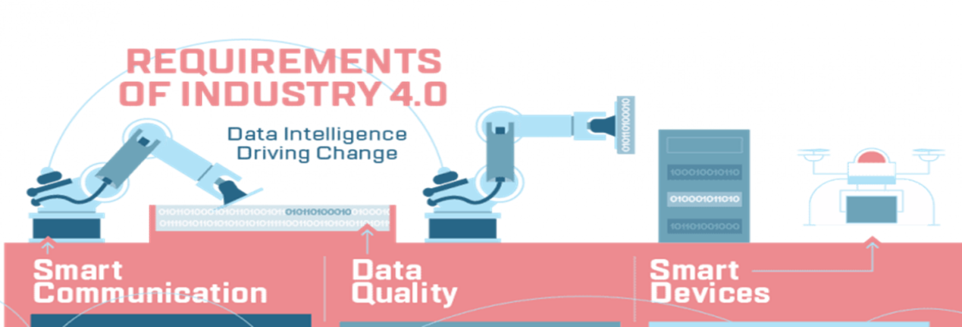

*Smart Communication*

Communication has advanced significantly over the last 200 years. The invention of the telegraph turned the world upside down, bringing instant communication across hundreds of miles. Locomotives started carrying large amounts of information and documents by railway around the same time. After the invention of the telephone, people were able to have conversations over long distances. Then came computer intranets. And finally, the expansion of connected intranets to the World Wide Web and the internet we use today. Ever since the 1990s, the pace of data communication has increased exponentially. Industry 4.0 is a communication and inter-connectivity revolution. The overwhelming amount of data communication is now too vast for humans alone to analyze and make decisions. The goal of Industry 4.0 is smart communication: Machines communicating with other devices leading to factory automation.

*Data Quality*

Data is the cornerstone of Industry 4.0. Factory automation is dependent on the collection and communication of data. However, data intelligence and communication are only as good as the quality of the data. If one portion of data is incomplete, the whole system can fail. The conversation about data collections needs to shift. For too long, collecting as much data as possible has been championed over gathering useful data that translates between systems. Actionable insights and automated decision-making by machines and computer systems require focus over the next decade to achieve Industry 4.0. In other words, the quality of data is more important than the quantity of data. A lot of low-quality data means more resources being consumed for less accurate outputs.

*Smart Devices*

An example of Industry 4.0 connected smart devices is visual sensors attached to robotic arms that send and receive data. It also includes equipment like autonomous robots that move products on the factory floor and move heavy materials at just the right time.Industrial smart devices use sensors to collect data to make autonomous decisions while simultaneously communicating with a more extensive system. Automated communication enables independent synchronization across an entire smart factory.

**The key technologies that underpin Industry 4.0 are as follows**:

*Cyber-Physical Systems (CPS):* Cyber-physical systems integrate computing, communication, and physical elements to create intelligent systems. CPS combines the physical world with digital technologies, enabling real-time monitoring, control, and coordination of physical processes. It involves the integration of sensors, actuators, and control systems with data networks.

*Big Data Analytics:* Big data analytics involves the collection, storage, and analysis of large volumes of data to uncover patterns, trends, and insights. It utilizes advanced algorithms and machine learning techniques to process and derive actionable information from diverse data sources generated by machines, sensors, and other digital systems.

*Advanced Robotics:* Advanced robotics involves the use of sophisticated robotic systems and machines capable of performing complex tasks. These robots are often equipped with AI, computer vision, and sensor technologies to interact with the physical environment and collaborate with humans in various industrial settings. Robotic systems can perform tasks with precision and efficiency, while AI algorithms enable autonomous decision-making based on real-time data. Automation leads to improved productivity, reduced errors, and the ability to handle complex tasks.

*Simulation*: Simulation tools or technologies within the industry 4.0 framework are intended to optimize business processes in all kinds of industries. They enable the recreation of virtual processes or technical systems in the real world, within a controlled and repeatable environment. Thanks to simulation, it is possible to identify bottlenecks and optimize production, analyze critical points in industrial processes (design, production, logistics, maintenance), reduce process implementation times, minimize costs and anticipate all kinds of scenarios that may emerge, thereby enhancing business resilience. There are multiple types of economic processes in which simulation is being used, such as inventory management, controlling production to improve the level of service and adapting to customer needs; or optimizing the quality levels related to the product delivery service, ensuring efficient use of resources and a reduction in delivery times.

*Integration:* Traditionally, industry management and control systems have been divided into analysis, management and execution systems (industrial computing); and control, supervision and communication equipment, i.e., all the connections that occur between the machines and the sensors. The evolution of these two worlds enhanced by the automation, standardization and integration of equipment has made it possible to integrate data generated by the different equipment, suppliers, and computer applications used in a company. While horizontal integration refers to the integration of the various IT systems used in the different stages of business manufacturing processes, vertical integration also focuses on the integration of IT systems, but at different hierarchical levels, to provide an end-to-end solution.

*Internet of Things (IoT)****:*** IoT refers to the network of interconnected physical devices, sensors, and objects embedded with software, electronics, and network connectivity. IoT enables the collection, exchange, and analysis of data from various sources, creating a seamless flow of information between machines, systems, and humans.

*Artificial Intelligence (AI) and Machine Learning:* AI encompasses technologies that enable machines to perform tasks that typically require human intelligence. Machine learning, a subset of AI, involves algorithms that allow systems to learn from data and improve performance over time. AI and machine learning play a vital role in Industry 4.0 by enabling automation, predictive analytics, and autonomous decision-making.

*Cybersecurity:* Digitization brings many benefits, but also certain risks and one of them is the increased level of exposure to cyberattacks and the repercussions that an event of these characteristics can have. From the theft of data or sensitive information to the deterioration of the corporate image and economic losses caused by a halt in activity. Faced with this situation, company investments in cybersecurity have increased in recent years. To this we must add all the regulations enforced by the EU, such as the approval of the NIS2 directive, which seeks to improve resilience and response capacity to cyberattacks, in public and private sectors; and the PIC Law (Protection of Critical Infrastructures) that ensures the protection of all installations, networks, systems, physical equipment, and information technology used to operate essential services (Administration, water, power, energy, space, chemical industry, nuclear industry, research facilities, health, financial and tax system, information technology, communications, and transportation).

*Cloud Computing:* Cloud computing provides scalable and on-demand access to shared computing resources over the internet. It enables the storage, processing, and retrieval of vast amounts of data and facilitates the deployment and management of complex software systems. Cloud computing allows organizations to leverage remote servers, software, and services for efficient data management and computation. Cloud computing is a model for enabling ubiquitous, convenient, on-demand network access to a shared pool of configurable computing resources (e.g., networks, servers, storage, applications, and services) that can be rapidly provisioned and released with minimal management effort or service provider interaction. It is worth mentioning the three service models available for cloud computing: Software as a Service (SaaS), Platform as a Service (PaaS), and Infrastructure as a Service (IaaS). All of these cloud computing solutions provide the flow of data to users over the internet, from cloud service providers’ systems to front-end clients and vice versa. However, the difference lies in the offerings. In the case of IaaS, the infrastructure is rented, and the user accesses it with an API or a panel. While the user manages the operating system, applications, and middleware; the vendors take care of hardware systems, networks, hard drives, data storage, and servers. In the case of PaaS, the third-party cloud service provider provides and manages the hardware and an application software platform, but the user is responsible for the applications that run on it and the data on which these applications are based. SaaS offers users a software application in the form of a service, i.e., the user can hire or use the software through the Internet, while the management is carried out by the cloud service provider.

*Additive manufacturing:* 3D printing is a type of additive technology that allows a three-dimensional reproduction of a design that has been previously created digitally. The application of this technology in industrial environments is what is known as additive manufacturing, i.e., a production system that allows complex and durable objects to be mass-produced, adding layers of material, such as plastic, ceramic, or metal, until the three-dimensional object is formed. The benefits of this technology applied to industry 4.0 include precision in product design, reduction of human errors in manufacturing, customization, reduced logistics and manufacturing costs, and great flexibility, agility, and adaptability for manufacturing lines.

*Augmented Reality:* Augmented Reality (AR) in the industrial world requires reliable and precise devices capable of visualizing, for example, 3D elements in high resolution, AI algorithms applied to image processing to detect the setting, and gesture recognition libraries, etc. The aim is to improve business processes including product design, using three-dimensional models visualized with layers of RA or mobile devices; manufacturing, using geolocated information that uses RA glasses to superimpose information and metadata in the real environment from automation and control systems; remote assistance, to carry out an activity under controlled supervision; work procedures that are displayed in augmented reality using animations to update the worker’s knowledge regarding a specific issue, etc.

These technologies work together to enable connectivity, automation, and data-driven decision-making in Industry 4.0 . By leveraging these key technologies, Industry 4.0 aims to create intelligent, interconnected systems that optimize processes, enhance productivity, enable predictive maintenance, support customization, and drive innovation across various industries.

**Example:**

To understand how Industry 4.0 systems can lead to better productivity, let's consider an example of a smart manufacturing facility:

In a smart manufacturing facility, various machines and equipment are connected through a network, forming a cyber-physical system. Each machine is equipped with sensors to collect real-time data about its performance, such as temperature, pressure, vibration, and energy consumption. This data is continuously transmitted to a central control system. The central control system uses advanced analytics and machine learning algorithms to analyze the collected data. It can identify patterns, anomalies, and performance trends. Based on this analysis, the system can make real-time adjustments to optimize the manufacturing process, improve efficiency, and reduce downtime.

For example, if the system detects a rise in temperature in a particular machine, it can automatically adjust the operating parameters or alert the operator to take corrective action. This proactive approach helps prevent equipment failures, reduces unplanned downtime, and increases overall productivity. Furthermore, the integration of CPS allows for enhanced coordination and collaboration between different machines and processes. For instance, in an assembly line, CPS can ensure that each component is precisely synchronized, minimizing errors and reducing waste. Machines can communicate with each other to determine the optimal workflow, adapt to changing production requirements, and dynamically allocate resources. This coordination leads to smoother operations, improved throughput, and higher productivity. Another aspect of CPS is the ability to leverage real-time data for predictive maintenance. By continuously monitoring the performance of machines and analyzing the data, the system can identify potential maintenance needs before equipment failure occurs. This predictive maintenance approach helps avoid costly breakdowns, reduces downtime, and maximizes productivity by scheduling maintenance during planned operational pauses.

**Three-layered framework of Industry 4.0:**

The three-layered framework of Industry 4.0 is a conceptual model that describes the organization and functioning of the various components and technologies within the industrial context. This framework is designed to help understand the different levels of connectivity, data flow, and decision-making processes involved in the implementation of Industry 4.0 technologies.



The three layers are as follows:

**Perception Layer(digitization**)**:** The perception layer, also known as the "sensing" or "physical" layer, is the foundational level of Industry 4.0. It deals with data acquisition from physical objects and processes. This layer consists of sensors, actuators, and other devices that collect data from machines, equipment, products, and the environment. The data collected include various parameters such as temperature, pressure, humidity, vibration, location, and more. These sensors are crucial in enabling the digitization and monitoring of physical processes.

**Network Layer( Data Analytics)** : The network layer, also called the "communication" layer, facilitates the transfer of data between the perception layer and the higher layers of the Industry 4.0 framework. It comprises various communication technologies and protocols that allow seamless connectivity and data exchange. Internet of Things (IoT) plays a significant role in this layer, enabling the integration and interaction of devices and systems. The data collected by the sensors in the perception layer are transmitted through the network layer to be processed and analyzed at higher levels. It involves data processing, analytics, and decision-making using advanced technologies such as artificial intelligence (AI), machine learning, big data analytics, and cloud computing.

**Information Layer**: The information layer, also known as the "cyber" or "digital" layer, is the topmost layer of the Industry 4.0 framework. This layer aggregates, processes, and analyzes the data received from the network layer to derive valuable insights, patterns, and trends. The information layer enables real-time monitoring, predictive maintenance, optimization, and intelligent decision-making to improve operational efficiency and performance.

The three-layered framework of Industry 4.0 demonstrates the hierarchical flow of data and information from the physical processes (perception layer) to the digital and analytical realm (information layer). This structure allows for greater visibility, control, and intelligence in industrial processes, leading to enhanced productivity, reduced costs, and improved innovation. It serves as a fundamental model for understanding how various technologies and components work together to drive the digital transformation of industries in the fourth industrial revolution.

**Value chain from the digital world to the real world:**

The value chain from the digital world to the real world refers to the process of transforming digital information, data, or designs into tangible products, services, or physical actions. This transformation involves a series of interconnected steps that add value at each stage, ultimately delivering a real-world output.

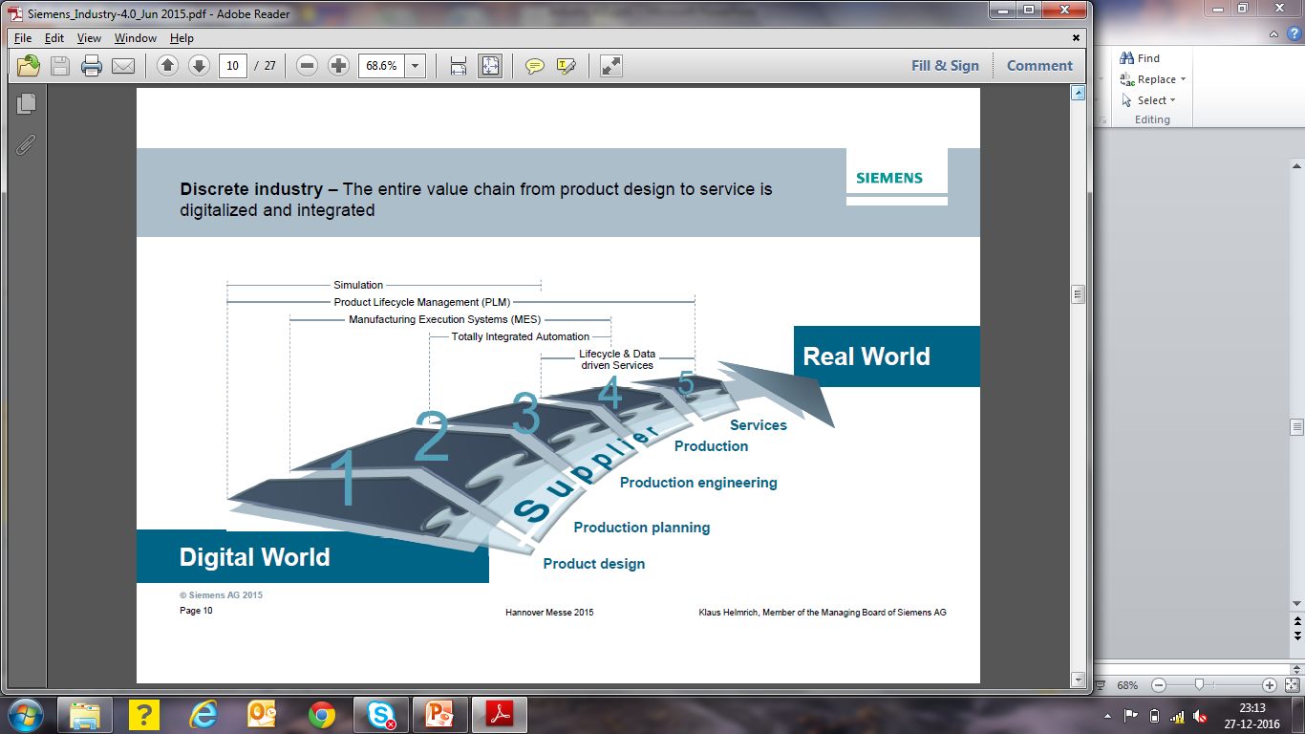

Let's explore the typical stages of this value chain:

*Digital Design and Modeling:* The process begins in the digital world with the creation of designs, models, or plans using computer-aided design (CAD) software or other digital tools. This stage involves conceptualizing and visualizing the product or service before it is physically produced.

*Simulation and Prototyping:* After digital designs are created, simulations and prototyping may occur. Virtual simulations can be performed to test the product's performance, identify flaws, and optimize its design. Prototyping involves creating physical samples of the product to validate its functionality and appearance.

*Manufacturing and Production:* Once the digital design and prototyping stages are complete, the real-world production process begins. Advanced manufacturing technologies, such as 3D printing, computer numerical control (CNC) machines, and automated assembly lines, may be employed to transform raw materials into the final product.

*IoT and Connectivity:* The products manufactured in the real world may be equipped with sensors and IoT devices. These embedded technologies allow the products to collect and transmit data back to the digital world, enabling real-time monitoring, maintenance, and data-driven insights.

*Supply Chain and Logistics:* The value chain also includes the management of the supply chain and logistics. Digital systems, such as enterprise resource planning (ERP) software and blockchain, may be used to optimize inventory, track shipments, and improve overall supply chain efficiency.

*E-Commerce and Digital Marketing:* In the digital-to-real world value chain, e-commerce platforms and digital marketing play a crucial role in promoting and selling products to consumers. Online marketplaces and digital advertising enable global reach and access to a broader customer base.

*Delivery and Customer Experience:* As products are physically delivered to customers, the real-world customer experience becomes paramount. Efficient delivery processes, quality control, and post-sales support are essential elements in this stage.

*Data Analysis and Feedback Loop:* Data collected from the real-world products can be analyzed in the digital world to gain insights into customer behavior, product performance, and market trends. This feedback loop allows for continuous improvement of the product and its design.

*Customer Feedback and Iteration:* Customer feedback from real-world usage provides valuable input for refining future product iterations. This iterative process, informed by data and customer insights, contributes to ongoing innovation and product enhancement.

The value chain from the digital world to the real world represents the seamless integration of digital technologies and physical processes, leading to greater efficiency, innovation, and customer-centrality. It demonstrates how the digital realm influences and enhances the traditional value chain, allowing companies to create more personalized, adaptive, and competitive products and services.